0.00 12.96 HOST: Two uninhabited Pacific Islands, more than 5,000 miles from the UK.

12.96 21.20 HOST: One will be inhabited by 14 British men, while a separate island will be home to 14 British women.

21.20 29.92 HOST: When pushed to the limits of human endurance, will it be brute power or mental strength?

29.92 30.92 HOST: The winds are day.

30.92 36.20 HOST: Who will have what it takes to stay alive?

36.20 43.96 HOST: Tonight we follow the women.

43.96 49.36 HOST: In 21st century Britain, old-fashioned ideas about men and women have disappeared.

49.36 53.40 HOST: And traditional gender roles have become blurred.

53.40 58.36 HOST: Women are often expected to do it all, combining childcare with excelling at work.

58.36 59.36 BEKI_29: I don't let that happen again.

59.36 60.36 BEKI_29: I don't know who's doing it.

60.36 62.36 BEKI_29: It's really, really embarrassing and unprofessional.

62.36 72.52 HOST: But a strip of all of the advantages of modern life are multitasking 21st century women better cut out for survival than men.

72.52 79.92 HOST: To find out, I'm abandoning 14 ordinary women to fend for themselves on a remote desert island.

79.92 90.96 HOST: They will be utterly alone.

90.96 93.68 SPEAKER_39 It's been with my family.

93.68 94.68 HOST: Filming everything themselves.

94.68 95.68 BELINDA: Right, you're filming me, filming you.

95.68 102.24 BELINDA: That is the biggest shucker I've ever seen.

102.24 103.92 HOST: They'll have to hunt for food.

103.92 105.92 SPEAKER_15 All right, you are.

105.92 106.92 HOST: For water.

106.92 109.00 SPEAKER_15 Yeah, it's collecting water now.

109.00 110.00 HOST: And for shelter.

110.00 115.08 HOST: Oh, for f***'s sake.

115.08 124.00 HOST: The women will be taken to the very edge of existence, living on the island for six weeks in the middle of tropical storm season.

124.00 126.00 HOST: It's like a tornado.

126.00 127.00 None It's terrifying.

127.00 130.00 SPEAKER_18 We need a radio is magic now.

130.00 132.00 SPEAKER_18 It's not a program.

132.00 133.00 BEKI_29: It's ridiculous.

133.00 141.16 BEKI_29: Just remember to how you felt when you felt shit, okay?

141.16 142.92 BEKI_29: And leave it there.

142.92 147.28 SPEAKER_34 When pitted against the extremes of nature.

147.28 150.92 SPEAKER_34 Have these Monday women go what it takes to survive?

150.92 151.92 GEORGIE_46: Guys.

151.92 158.96 GEORGIE_46: That is a big s***.



158.96 174.76 BELINDA_32: People hold a lot of their self worth and things like money, what they're able to buy, what car they have, clothes they have, makeup, how beautiful they are.

174.76 179.44 BELINDA_32: When all of that's gone on the island, I think it all comes down to what sort of a person you are.

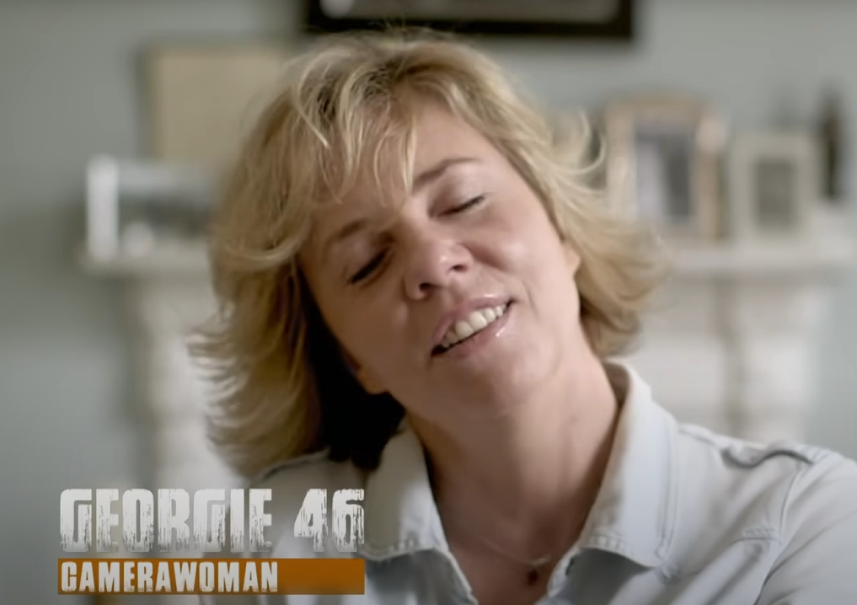

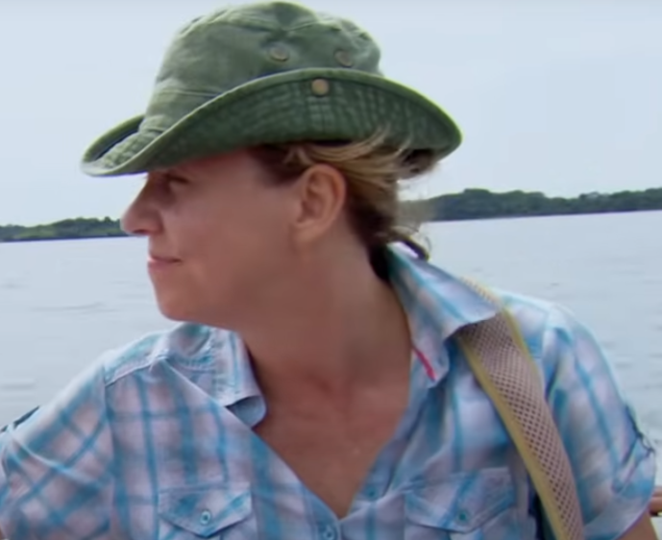

179.44 182.24: I think you can be slightly mental to want to do this, right?

182.24 185.16 GEORGIE_46: I think you're going to be slightly off your tree. **TO:CAM**

185.16 188.60 GEORGIE_46: As human beings, it's the closest we're going to come to a reboot.**TO:CAM**

188.60 194.16 HOST: I'm about to abandon 14 British women on a remote and inhabited Pacific island.

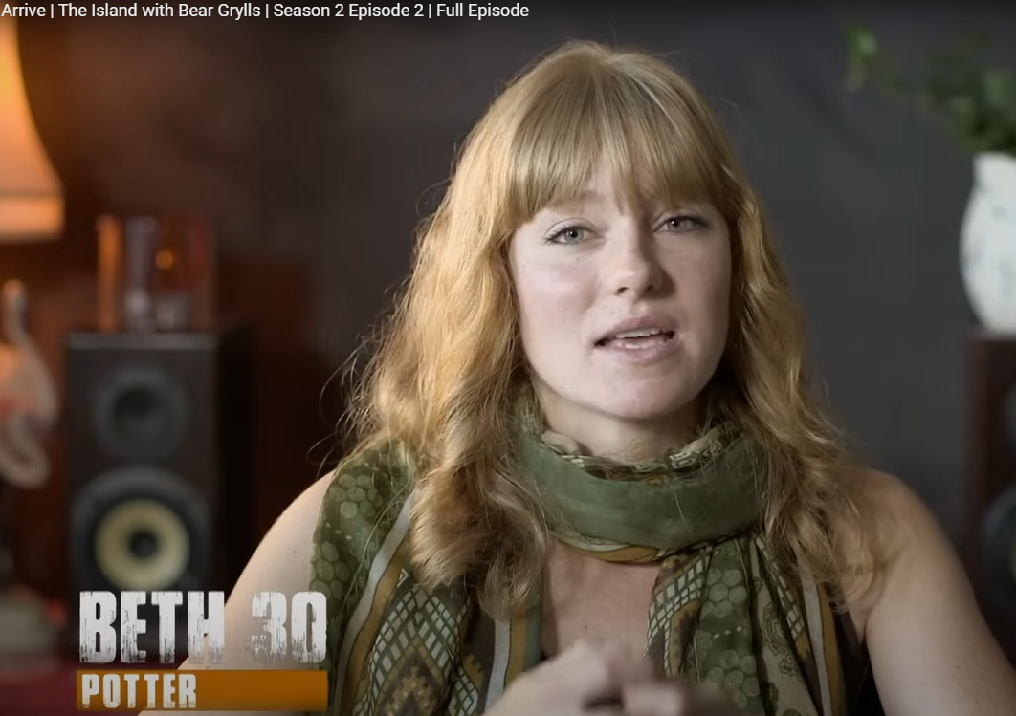

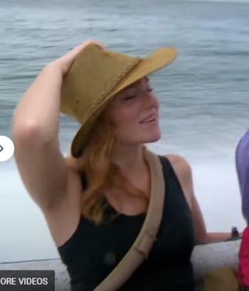

194.16 202.52 BETH_30: I want my daughter to know that her mom is actually quite brave and she's not just this person that's there to make tea. **TO: CAM**

202.52 205.00 BETH_30: I want to show her that you can do anything.

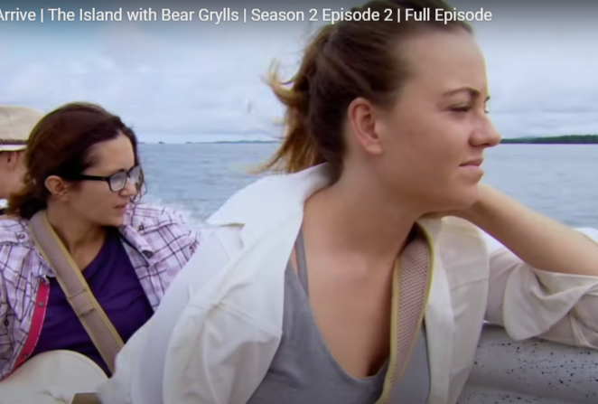

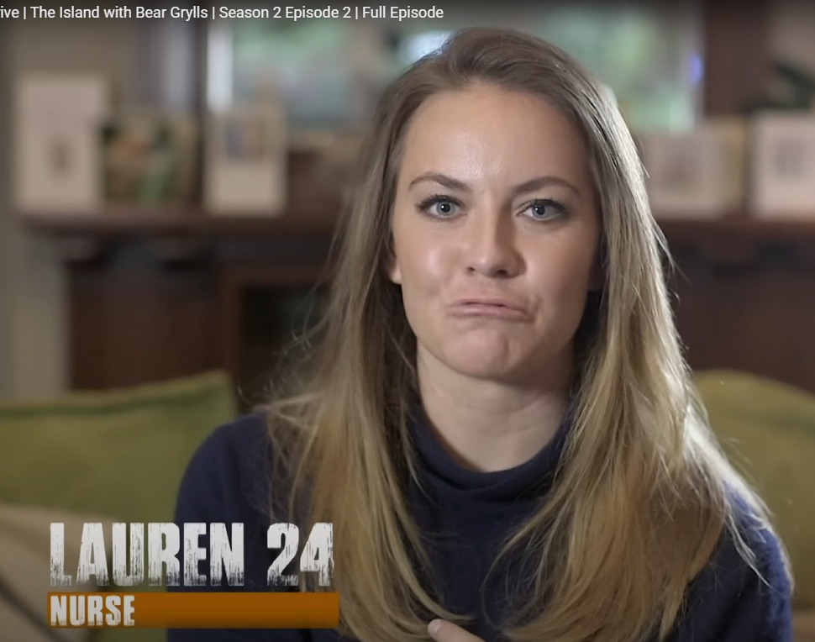

205.00 212.80 LAUREN_24: We're looking forward to going back to the hunter-gatherer animalistic roots and finding your own food.

212.80 219.08 LAUREN_24: I think it's only by pushing yourself to these extremes that you get to find out who you truly are.

219.08 224.20 HOST: These are ordinary women with no previous experience of surviving in the wild.

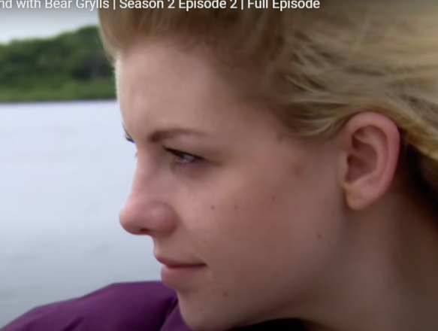

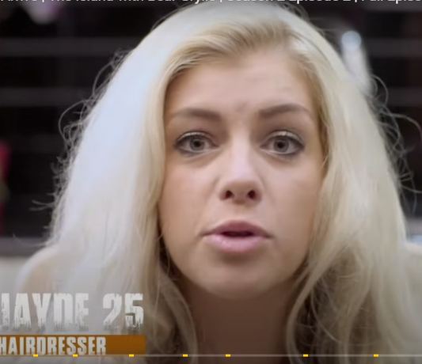

224.20 229.40 JAYDE_25: I'm not going on because I can kill an animal and I know I can survive and I can chop down trees.

229.40 233.48 JAYDE_25: I'm doing this because I can't, but I'm eager to see if I can.

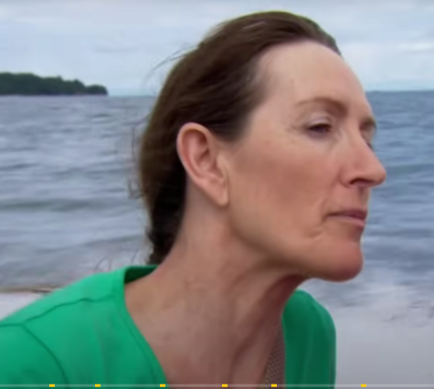

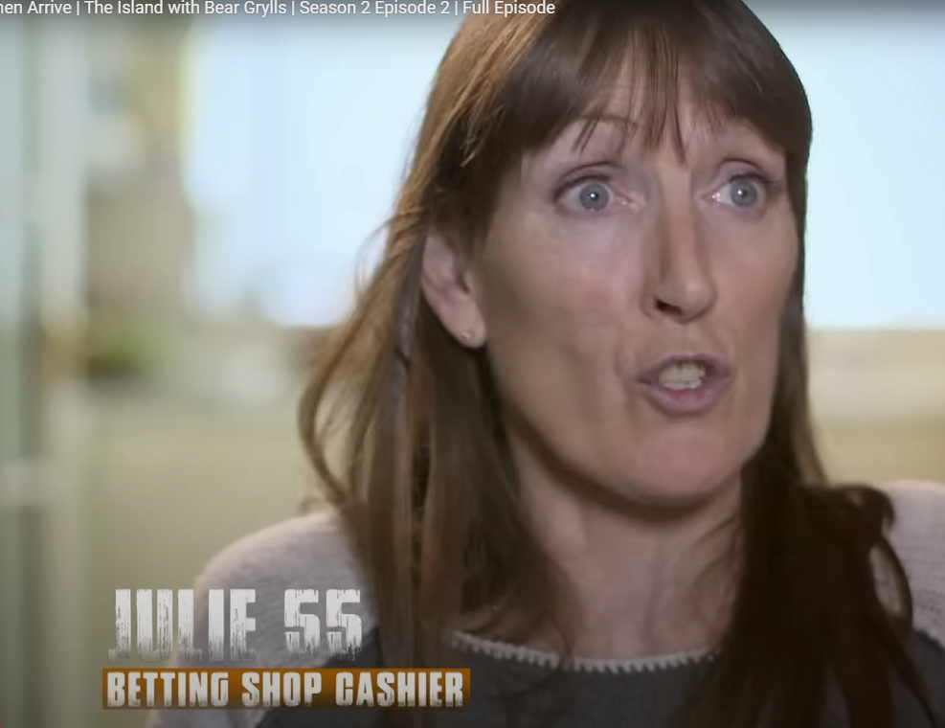

233.48 234.48 JULIE_55: It's the adventure.

234.48 236.32 JULIE_55: There's so much I haven't seen.

236.32 238.36 JULIE_55: There's so much I haven't done.

238.36 241.44 JULIE_55: I'm running out of time and I might be running out of health.

241.44 246.56 JAYDE_25: How fast are we going right now?

246.56 254.00 HOST: We're going to go really fast.

254.00 265.08 HOST: I think people often think that to be good at adventure or survival you've got to have big muscles, but actually in the battle to stay alive it's one in here (mind) and in here (heart), not on these.

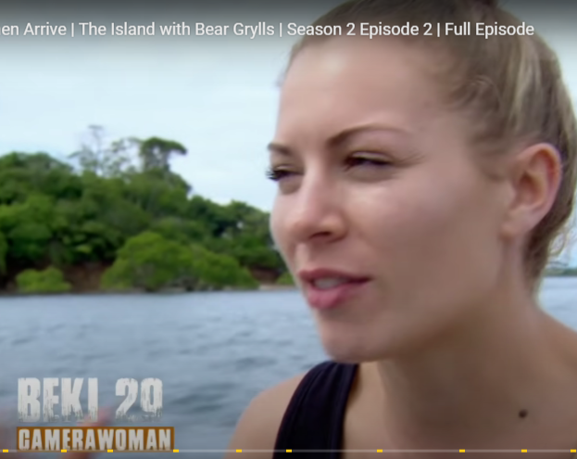

265.08 268.92 BEKI_29: We're definitely on the island, all of us girls.

268.92 275.52 BEKI_29: I think we will not only survive, but I think we'll thrive.

275.52 278.28 HOST: This is your island, straight ahead.

278.28 282.08 SPEAKER_33 There's a lot of beach.

282.08 289.24 SPEAKER_35 There are a lot of currents around this, okay?

289.24 295.28 HOST: So I'm going to try and find these little areas of slack water to get you in.

295.28 301.24 HOST: Unpredictable riptides and hidden rocks make these waters treacherous.

301.24 305.68 HOST: This is the closest I can get the boat to the shoreline.

305.68 307.84 HOST: I'm not going to sugar coat this for you guys.

307.84 309.88 HOST: It is going to be hard.

309.88 311.56 HOST: It's going to be hard physically.

311.56 313.68 HOST: It's going to be hard emotionally.

313.68 320.52 HOST: And the thing to remember is positivity, positivity, positivity.

320.52 324.00 LAUREN_24: The white beaches in there, the sun that we were dreaming of.

324.00 328.00 JULIE_55: I was all keen until I got to this point and now I'm really panicking.

329.00 331.52 JULIE_55: How deep is that?

331.52 333.44 HOST: You know, it is going to be out of your debt.

333.44 335.08 HOST: There are rocks in there.

335.08 336.40 HOST: Just be smart.

336.40 341.96 HOST: To get to the island, the women have no choice but to swim to the shore in the clothes they're wearing.

341.96 344.88 JULIE_55: It's the thought of being all night.

344.88 346.88 JULIE_55: No dry clothes and no fire.

346.88 348.88 SPEAKER_32 Because we have to make mistakes.

348.88 350.88 FRAN: Don't think about it. **to:julie**

350.88 351.88 FRAN: Don't think about it. **To: julie**

351.88 352.88 SPEAKER_32 Just one more one.

**Note: Julie is already having a meltdown we havent even started**

352.88 353.88 JULIE_55: It's going to take hours.

353.88 354.88 JAMIE_30: We'll just cuddle each other tonight.

354.88 355.88 JAMIE_30: Yeah.

355.88 356.88 HOST: Everyone's allowed the old wind.

357.76 360.24 HOST: Once we get you in the water, you'll be done with it.

360.24 361.24 JULIE_55: Yeah.

361.24 362.24 JULIE_55: Yeah?

362.24 363.24 HOST: Then it's all in front of you.

363.24 364.24 SPEAKER_28 It's all uphill for me.

364.24 365.24 HOST: You'll be great.

365.24 366.24 HOST: You'll be great.

366.24 369.24 JULIE_55: It's all uphill for me.

369.24 370.24 SPEAKER_28 Yeah.

370.24 371.24 HOST: You're good to go.

377.24 379.24 HOST: Let's go, Fred.

379.24 385.24 HOST: The women take with them bags and cases containing their filming equipment and medical supplies.

386.12 388.12 HOST: This is croc territory.

388.12 391.12 HOST: Let's get you out of the water as fast as we can.

393.12 394.12 HOST: Okay, let's go.

401.12 404.12 HOST: From this moment on, they'll be completely alone.

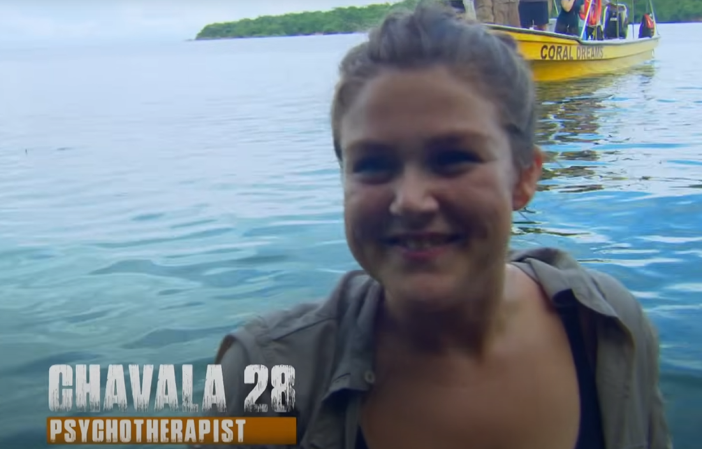

404.12 405.12 Abby: who are you?

GEORGINA: George.

**Georgina and becky are camera holders, and one more unknown camera person**

405.12 406.12 GEORGINA: George, excellent.

406.12 407.12 BEKI_29: Abby im Becky.

407.12 408.12 ABBY: Becky, hi, Becky.

408.12 409.12 BEKI_29: It's happy.

409.12 410.12 BEKI_29: Hi.

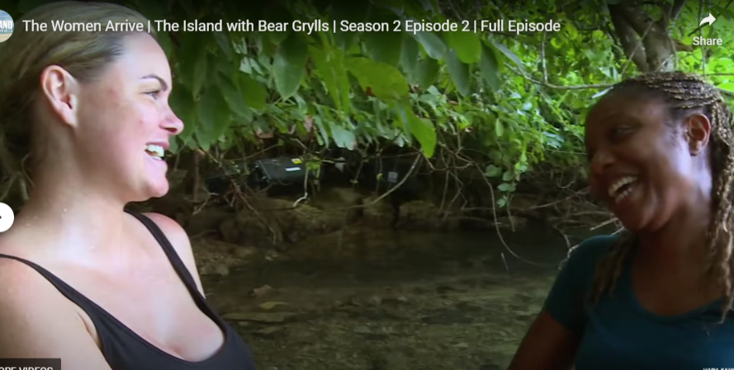

**Jamie <-> Belinda**

412.12 414.12 CHAVALA_28 So nice to meet you to GEORGIE.

414.12 415.12 CHAVALA_28: I'm CHAVALA.

415.12 416.12 CHAVALA_28 Nice to meet you.

418.12 419.12 LAUREN: What do you do?

419.12 420.12 CHAVALA_28 I'm a psychotherapist.

420.12 421.12 LAUREN Oh, my God.

421.12 422.12 LAUREN Yeah.

422.12 425.12 BELINDA: BELINDA, Jamie, **To Each other**

425.12 426.12 BELINDA: What's your name? **To: beki**

426.12 428.12 BELINDA: Oh, Becky, hello.

428.12 429.12 BELINDA: This is so emotional :to Julie

**Belinda and julie hug**

429.12 430.12 BELINDA: What's the amazing thing?

430.12 432.12 HOST: Well, that was suitably chaotic.

432.12 433.12 HOST: You know, it's four o'clock.

433.12 436.12 HOST: It's going to get dark here in a couple of hours.

436.12 438.12 HOST: And already, you know, there have been 15 minutes.

438.12 440.12 HOST: Chat, chat, chat on the beach.

440.12 442.12 HOST: They need to work hard, get moving.

442.12 444.12 HOST: Yeah, theres nothing I can do.

444.12 446.12 HOST: These are things they're going to find out.

447.12 449.12 HOST: It's time for me and the crew to leave.

449.12 452.12 HOST: We won't be back till the end of the experiment.

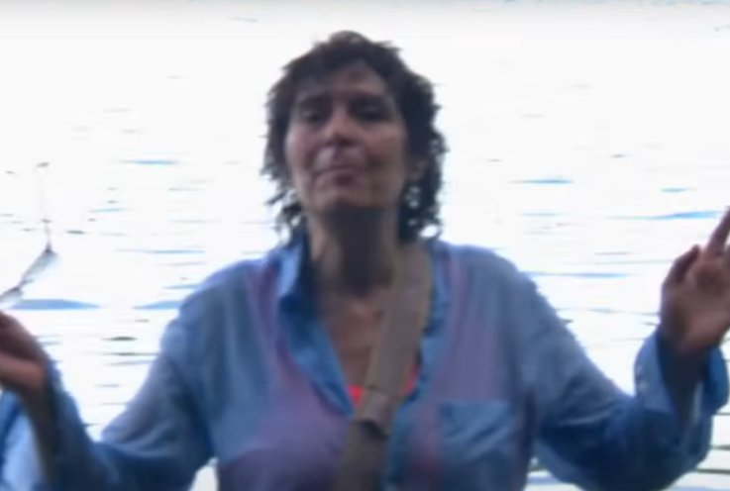

FI_58 Camera woman

454.12 457.12 FI_58: Oh, I'm peeing.

457.12 460.12 FI_58: I'm peeing, I'm peeing, I'm peeing.

460.12 461.12 FI_58: I still need to pee.

461.12 463.12 BEKI_29: I don't want to pee through my trousers.

463.12 464.12 BEKI_29: I can't believe you're on it.

464.12 465.12 BELINDA: Do you want to pee?

467.12 473.12 HOST: The women's home for the next six weeks is this remote, uninhabited Pacific island.

473.12 482.12 HOST: To make sure they have a fighting chance of survival, I've ensured there is enough water, indigenous animals, and vegetation to keep them alive.

482.12 487.12 HOST: But only if they have the ingenuity to find it, catch it, and kill it.

487.12 491.12 HOST: I've dropped the group in the most inhospitable part of the island.

491.12 495.12 HOST: There's unforgiving jungle and deadly creatures all around.

495.12 500.12 HOST: Now, just two hours before sunset, the group need to move away as quickly as they can.

500.12 501.12 BEKI_29: Are you still weeing, Jayde?

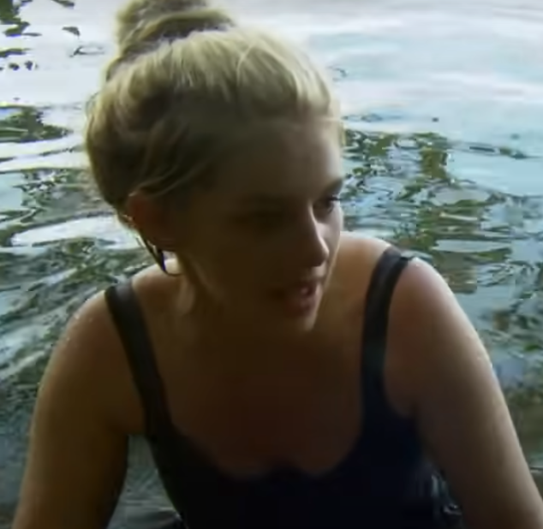

501.12 503.12 JAYDE_25: I'm weeing.

503.12 506.12 JAYDE_25: I need to find that peaceful moment where I can actually wee.

506.12 508.12 JAYDE_25: But I'm not the things I'm weeing.

508.12 510.12 JAYDE_25: And then I push more and I'm weeing more.

510.12 512.12 JAYDE_25: I think it's because I've held it in so long.

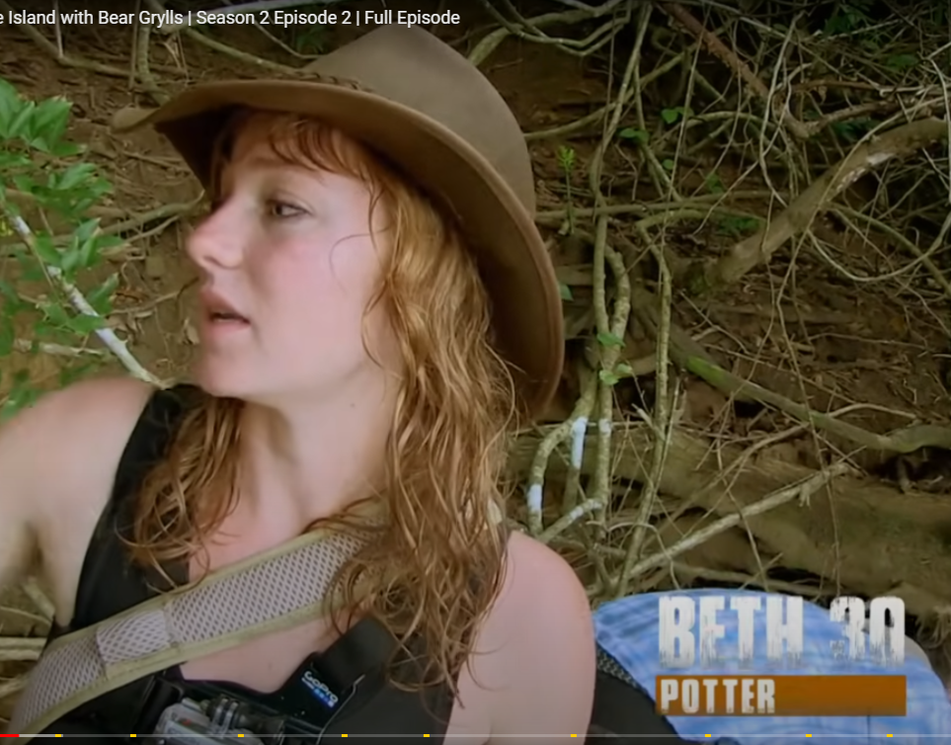

512.12 516.12 BETH_30: Guys, it's really dense up here, so we need to get moving.

516.12 519.12 BETH_30: We're just going to try and take all the kit up this slope, basically.

519.12 524.12 BETH_30: Bring it up because I think the tide's coming in, and then try and find some way to fucking sleep.

524.12 526.12 FI_58:: Can you take this camera, of course?

(PEEING)

526.12 531.12 HOST: All of the women will be filming but 4 of the group are trained and experienced camera operators.

531.12 533.12 HOST: Hello again.

533.12 537.12 HOST: They'll be living under exactly the same conditions as everyone else.

537.12 539.12 ABBY: Please, could you just push me at my back?

539.12 541.12 ABBY: No, it's my weight. I can't get it up.

541.12 542.12 BEKI_29: Here, wait.

542.12 544.12 BEKI_29: That's it. That's what I need.

544.12 549.12 HOST: The women have no food and just one day's supply of drinking water.

549.12 551.12 JAMIE_30: Thank you.

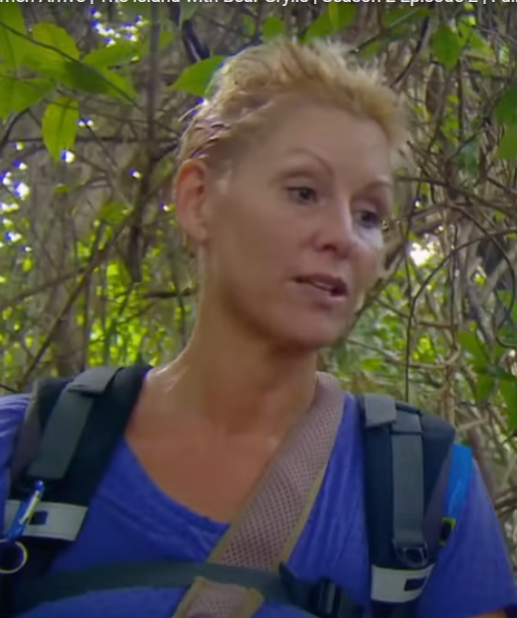

Abby

551.12 554.12 JAMIE_30: We need a decent place to sleep tonight because it's nearly dark.

554.12 557.12 JAMIE_30: We're not going to have it here. We need to move.

557.12 558.12 BEKI_29: We really do.

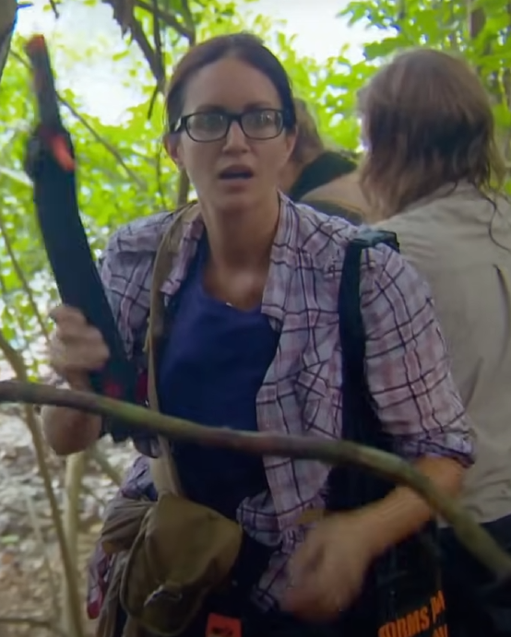

558.12 560.12 KATE_34: Right, who wants to carve the way? **TO: ALL**

560.12 568.12 HOST: To stand any chance of surviving, they've been provided with three knives, three machete and some basic fishing equipment.

568.12 571.12 JAMIE_30: Anybody that's using a knife, just tail us.

571.12 573.12 JAMIE_30: Don't whack it out.

573.12 577.12 JAMIE_30: Guys, are we going right or straight?

577.12 579.12 SPEAKER_18 Guys, shall we get together and have a chat?

579.12 580.12 SPEAKER_18 Well, let us go, Joy.

580.12 582.12 SPEAKER_18 Can we come up to you?

583.12 588.12 HOST: With little daylight left, the group's priority must be to find a safe place to camp and quickly.

588.12 591.12 JAMIE_30: We can't just come off a boat and stay in the same place. **TO: ALL**

591.12 593.12 JAMIE_30: 100%. 100%.

593.12 595.12 JAMIE_30: Do you want to lead the way? **TO: JAMIE TO ABBY** **SHAKE PERSON (ABBY)**

595.12 597.12 JAMIE_30: Make a decision. You lead the way. **TO: ABBY**

597.12 601.12 JAMIE_30: Anywhere you think looks the clearest, we'll follow you. **TO:ABBY**

**ABBY PERSON IS MADE LEADER TO FIND A GOOD PLACE TO STAY**

601.12 603.12 BEKI_29: I'm not going that way, right?

603.12 607.12 BEKI_29: It's more dense and the light is through over here, so I want to go over here.

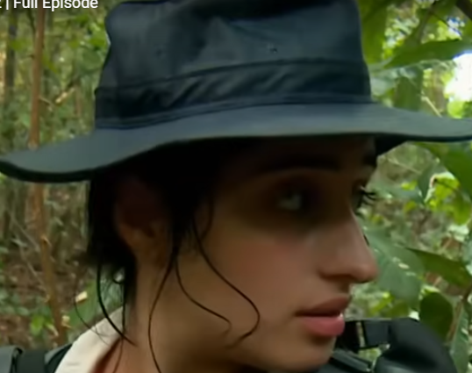

607.12 610.12 KATE_34: Guys, be really careful when you come in on this trail.

610.12 612.12 JAMIE_30: I'm still going up. **TO:ALL**

612.12 615.12 JAMIE_30: Keep going. I need to get the fuck out.

615.12 618.12 JAMIE_30: Right, stay still. We've got dinner.

618.12 620.12 JAMIE_30: What is it?

620.12 622.12 BEKI_29: Snake.

622.12 624.12 BEKI_29: It's right near me.

624.12 627.12 BEKI_29: A huge fucking snake came towards me.

627.12 629.12 BEKI_29: I think what you need to do...

629.12 631.12 BEKI_29: Fucking hell.

631.12 633.12 BEKI_29: It's going up the tree, girls.

633.12 635.12 BEKI_29: Shall I just chop its head off?

635.12 637.12 JAMIE_30: It came right at me.

637.12 638.12 BEKI_29: What? What's head?

638.12 640.12 JAMIE_30: It came straight towards me.

640.12 642.12 JAMIE_30: And he always stood on it.

642.12 644.12 JAMIE_30: That's why I ran away.

644.12 646.12 JAMIE_30: Oh, fuck.

646.12 649.12 JAMIE_30: I'm going to fucking die on the day. **TO: BETH**

649.12 652.12 BETH_29: You're not going to die. You are not going to die. **TO: JAMIE**

652.12 654.12 JAMIE_30: It came right towards me like that.

654.12 657.12 ABBY: Just breathe slowly and walk up to me now.

657.12 659.12 BEKI_29: How are you going to sleep in this? I hope…

659.12 660.12 BEKI_29: Hold on. What's her name?

660.12 661.12 ABBY: Jamie.

661.12 662.12 ABBY: Jamie, come to me.

662.12 664.12 BEKI_29: Oh, my God. I can't even...

664.12 665.12 ABBY: Right, I'll come to you.

665.12 667.12 SPEAKER_38 Oh…

668.12 671.12 JAMIE_30: To be honest, I'm frightened of everything.**TO:CAM**

671.12 676.12 JAMIE_30: Bugs and snakes and crocodiles and sharks.

676.12 680.12 JAMIE_30: But I really, really want to overcome the fear.

682.12 686.12 JAMIE_30: Materialistic things really shouldn't matter.

686.12 690.12 JAMIE_30: But unfortunately, they do matter a lot to me.

690.12 696.12 JAMIE_30: I can't imagine what it's going to be like going back to complete and utter basics.

696.12 699.12 JAMIE_30: It might change me into a new woman completely.

699.12 701.12 JAMIE_30: I have no idea.

701.12 705.12 JAMIE_30: Oh, I was on that one for two minutes and a snake attacked me. Fuck me.

705.12 707.12 JAMIE_30: I don't want a snake coming towards me.

707.12 709.12 ABBY: Take a deep breath, please. **TO:JAMIE**

709.12 712.12 ABBY: Just stand still and breathe in.

712.12 714.12 ABBY: Right, and breathe out.

714.12 716.12 ABBY: It's not going to get you.

716.12 718.12 BEKI_29: It looks like it's coming.

718.12 720.12 ABBY: It's bloody not. Stop fucking looking for it.

**ABBY IS COMFORTING JAMIE**

720.12 724.12 JAMIE_30: So, basically, the whole place is crawling the snakes.

724.12 726.12 JAMIE_30: Go on, move on.

727.12 730.12 JAMIE_30: Keep moving. I want to get out of here.

730.12 735.12 HOST: When you're pushing through dense jungle into the unknown, everything is a potential threat.

735.12 743.12 HOST: You've got caiman crocodiles, you've got snakes, you've got wild pigs, all of which are most likely to attack when they're surprised.

743.12 748.12 HOST: You let your guard down, the wild is going to bite you on the backside hard.

748.12 750.12 JAMIE: I feel like everything's crawling. **TO:ABBY**

750.12 751.12 ABBY: It's not.

751.12 757.12 ABBY: You've got to try and just take your mind away and pretend you're walking through some lovely area of a botanical garden.

**Note:** ABBY**comforting Jamie**

759.12 761.12 BECKI: Oh, shit, they're yucca.

761.12 762.12 BECKI: Oh, where?

762.12 764.12 SPEAKER_02 You're going to hear this.

765.12 767.12 CHAVALA: We've got a yucca.

767.12 770.12 SPEAKER_02 Guys, we need to get our priorities straight.

770.12 772.12 HOST: It's an early win.

772.12 775.12 HOST: They've identified a valuable source of carbohydrate.

775.12 777.12 JAMIE_30: We're getting too excited about yuka.

777.12 781.12 JAMIE_30: I'm actually quite concerned about sleeping, not yuka.

782.12 785.12 GEORGINA: This is nuts. I didn't know places like this existed.

786.12 787.12 BETH: Oh, my hair.

787.12 789.12 BETH: It's caught on a vine.

789.12 792.12 BELINDA: Guys, there's spikes on this that you can't even see. **TO:ALL**

792.12 793.12 BEKI_29: We're getting denser.

793.12 795.12 BEKI_29: Is everybody happy to continue through this?

ABBY: UHHH

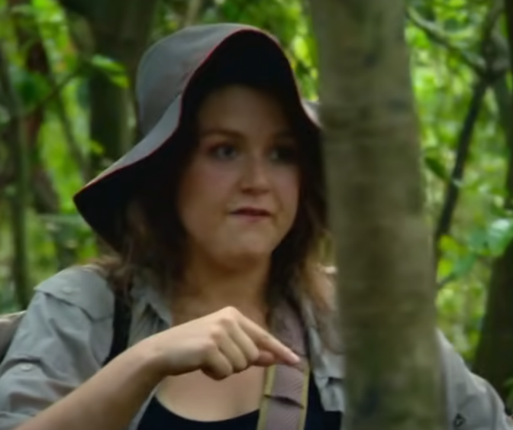

795.12 800.12 CHAVALA: Well, I think we need to think about how much sunlight we have left.

800.12 805.12 JAMIE_30: If I have to, I'll walk through the dark because I am not sleeping here because of that snake.

805.12 806.12 CHAVALA: I'm with you on that one.

806.12 807.12 JAMIE_30: I don't know what else is here.

807.12 812.12 HOST: With light running out fast, the women are no closer to finding a beach to set up camp.

813.12 819.12 BEKI: Guys, where we just stopped, where there is quite a big open space, this might be a good place for just base.TO:ALL

819.12 820.12 ABBY and CHAVALA: Let's do it.

820.12 821.12 CHAVALA: Right.

823.12 830.12 JAMIE_30: I really, really do feel like I want to get out of this area because I feel like we've made absolutely zero progress. **TO:CAM**

**JAMIE DOESN’T HAVE HIGH HOPES FOR WHAT THEY HAVE SO FAR**

830.12 832.12 JAMIE_30: Let's get out of here.

832.12 836.12 JAMIE_30: It's really making me quite anxious and stressing me out.

836.12 844.12 HOST: 14 British women have been abandoned on a remote Pacific island with nothing but the closest stand-up in and a few basic tools.

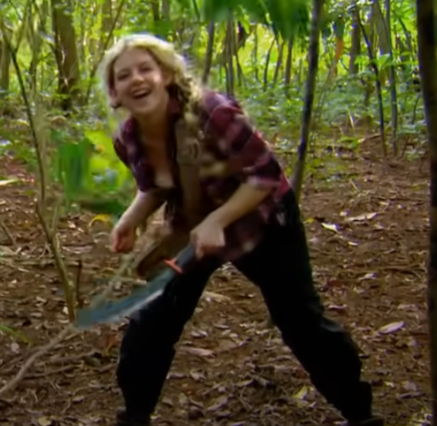

846.12 847.12 JAYDE: Sorry, tree.

849.12 860.12 HOST: All I want to find out is, has all of this cushioning that civilization has experienced, has it made us totally lose touch with that survival instinct that I believe is deep within us all?

860.12 861.12 HOST: OK.

862.12 872.12 HOST: With night closing in, the women have decided to abandon their search for a beach and set up camp in the jungle, taking their chances with the deadly critters.

872.12 879.12 HOST: Strength isn't an outward thing, it's an inner thing, it's an inner quality, and whether you're a man or a woman, you can have that.

879.12 882.12 HOST: It's about how you react to the hardship.

886.12 888.12 JAYDE: Conductor, like the little...

888.12 889.12 JAYDE: rain.

893.12 900.12 JAMIE_30: Rain, rain, go away, come again when we get off the sailing.

900.12 904.12 SPEAKER_14 Just got changed and now it's raining, so I've only got me normal pants.

904.12 906.12 HOST: If the women are to survive,

906.12 919.12 HOST: they'll need to live through six weeks of the tropical storm season. At its worst, the torrential rain can dump up to an inch of water in an hour.

919.12 927.12 BEKI_29: My current knickers and trousers are wet through, so I feel like I've wet myself a bit, not wearing a shitty nappy.

927.12 932.12 KATE_34: I have dry socks though, which are in my bra,

932.12 934.12 KATE_34: keeping me even drier.

934.12 936.12 GEORGINA: Yeah, that's a good idea.

936.12 942.12 HOST: Without shelter, the only protection the women have from the elements is their raincoats and ponchos.

942.12 944.12 FI_58: It's absolutely hideous.

944.12 946.12 FI_58: It's going to get dark soon.

946.12 956.12 FI_58: And that will mean that there's no heat at all, so we will go to bed cold and damp, and we'll have to sleep on a cold and damp jungle floor. **TO:CAM**

960.12 962.12 JAYDE: Look, my fucking hands.

962.12 966.12 JAYDE: I have a hairdresser and, like, I can't afford this.

967.12 977.12 JULIE: You want to see the water coming out of my socks on film?

979.12 983.12 HOST: 7pm, and the women are determined to get a fire started.

983.12 988.12 FI_58: If you can find another tree with some of that, great, but that'll burn very, very quickly.

988.12 990.12 ABBY: It's cold. And it's horrible.

990.12 992.12 ABBY: I'm trying to actually not even think about it.

992.12 999.12 ABBY: That's what I'm trying to do at the moment, and not focus about the dark, because if we don't get a fire and we sit down, awful.

999.12 1005.12 HOST: After just two days' survival training, Becky, Georgina and their team have made a bow and drill.

1005.12 1009.12 GEORGINA: And we moved this really slow and little Becky.

1009.12 1012.12 BECKY: I like it long and I like it slow.

1014.12 1020.12 HOST: Spinning one piece of wood against another should create enough friction to produce a burning ember.

1020.12 1022.12 FI_58: Honestly, who'd be a bloody caveman?

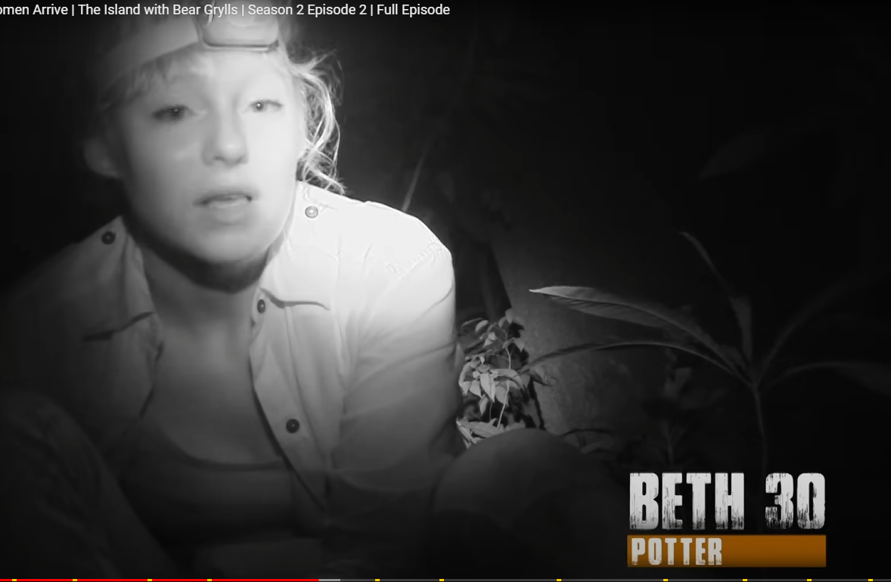

1025.12 1026.12 GEORGINA: Mm!

1026.12 1028.12 BEKI: We've done it once. We'll do it again.

1028.12 1030.12 SPEAKER_01 We can do this, girls. We can do it. We can do it.

1030.12 1032.12 SPEAKER_18 Right. Right, OK.

1032.12 1038.12 BETH: We're all so desperate to make fire, and the conditions are just so wet.

**BETH IS NOT HAPPY ABOUT THE FAILURE OF A FIRE**

1038.12 1043.12 BETH: I just have a feeling we're going to stay up all night and try and make fire.

1043.12 1045.12 SPEAKER_28 To any smoke, I'm making my roll.

1046.12 1048.12 SPEAKER_28 How long do you think the girls have been at it now?

1048.12 1052.12 ABBY: Three hours. Maybe more than three hours.

1052.12 1054.12 CHAVALA_28: These women I'm with are amazing.

1054.12 1061.12 CHAVALA_28: I've gone from absolutely terrified to sure...

1061.12 1063.12 CHAVALA_28: thrill and enjoyment.

**CHAVALA IS SUPPORTIVE OF THE GROUP REGARDLESS OF THE TIME ITS BEEN TAKEN FOR A FIRE.**

1063.12 1065.12 JULIE: Oh, there's tons of smell.

1065.12 1067.12 JULIE: It's like a friggin' wick one.

1067.12 1069.12 FI: Keep going.

1070.12 1072.12 SPEAKER_09 Don't think I can hold it much longer.

1072.12 1073.12 SPEAKER_09 Aah!

1074.12 1076.12 SPEAKER_09 Bloody good ember.

1076.12 1077.12 BELINDA_32: Are we going for it?

1077.12 1079.12 BELINDA_32: Maybe it's going too far.

1082.12 1083.12 None Yes.

1085.12 1086.12 GEORGIE_46: Are we nearly there?

1086.12 1087.12 GEORGIE_46: Here we go!

1087.12 1088.12 SPEAKER_38 Oh, my God!

1088.12 1090.12 SPEAKER_38 Wow! Let me get you off the air!

1090.12 1091.12 None Oh, my God!

1091.12 1093.12 None Oh, my God!

1094.12 1095.12 None Yeah!

1095.12 1096.12 None Yeah!

Note: Made Fire

1098.12 1099.12 BEKI:: Amazing!

1099.12 1103.12 BEKI: I'd just like to do this by persistence, persistence, persistence.

1104.12 1107.12 HOST: Becky and her team's determination has paid off.

1107.12 1108.12 BELINDA: I'm having a little fire.

1108.12 1110.12 BELINDA: Fucking child one!

1110.12 1117.12 HOST: After just five hours of trying, these women have achieved what took mankind hundreds of thousands of years.

**BEKI HAS HELPED THE TEAM BUILD A FIRE**

1117.12 1120.12 SPEAKER_27 Guys, how are we actually feeling about the fire?

1120.12 1122.12 SPEAKER_27 CHEERING

1124.12 1130.12 HOST: But almost more importantly, what it does for the women is going to give them a sense that they're gaining control of their environment.

1130.12 1132.12 SPEAKER_18 Is everyone stripping off?

1133.12 1135.12 SPEAKER_18 I've just got my dress stuck in my knickers.

1135.12 1137.12 SPEAKER_18 Oh, Jesus!

1137.12 1139.12 GEORGINA: I don't want to sound too cocky too early.

1139.12 1140.12 FI: I don't think we should.

1140.12 1144.12 GEORGINA: I don't think we should at all, but right now, this is...

1144.12 1145.12 FI: We're winning.

1151.12 1154.12 JAMIE_30: Jesus! Jesus! Jesus!

1154.12 1157.12 JAMIE_30: Fucking... Fuck me!

1157.12 1159.12 JAMIE_30: What the fuck is that?

1159.12 1161.12 JAMIE_30: Please tell me that's not a spider.

1161.12 1163.12 SPEAKER_21 It's that big crab over there. Can you see it, Jo?

1163.12 1166.12 JAMIE_30: Oh, my God, there's no way I can sleep here.

1167.12 1168.12 JAMIE_30: Fucking hell!

1168.12 1169.12 JAMIE_30: Fucking hell!

1169.12 1171.12 JAMIE_30: We're not staying here tomorrow.

1171.12 1176.12 JAMIE_30: We're all going together and we're going that way, and we're not going to stop until we get out of here.

1177.12 1179.12 BELINDA_32: Ladies got crabs.

1188.12 1192.12 HOST: The women have had a restless first night on the damp, jungle floor.

1192.12 1202.12 JULIE_55: I tried to have some sleep, but the noises in the night and the crabs that were creeping up on us, I just sat up all the time with the torch.

1202.12 1204.12 JULIE_55: They had torch like that.

1204.12 1206.12 ABBY: I did. I woke everybody up with my farts.

1206.12 1210.12 JAMIE: You did about five or six big, loud ones.

1210.12 1212.12 ABBY: Yeah, well, no, no, no, they weren't loud.

1212.12 1213.12 ABBY: Oh, no.

1213.12 1215.12 ABBY: You just decided to sleep well.

1215.12 1217.12 BEKI_29: You are, aren't you?

1218.12 1223.12 JULIE_55: It's just that yuca, and it's a bit like a potato.

1223.12 1228.12 HOST: Despite lack of sleep, Julie's playing mum, and has rustled up a little breakfast.

**JULIE HELP COOK FOOD FOR THE GROUP**

1229.12 1232.12 SPEAKER_19 I'm very excited. We've got our first food.

1232.12 1234.12 SPEAKER_19 I think, oh, hang on.

1234.12 1235.12 SPEAKER_19 Oh, my way.

1235.12 1238.12 BEKI_29: Not as nice as normal food.

1238.12 1241.12 BEKI_29: When we're actually starving, it'll be absolutely amazing.

1241.12 1243.12 HOST: The group may have found food.

1243.12 1244.12 BELINDA: Add to the collection.

1244.12 1245.12 BELINDA: What is that?

1245.12 1247.12 BELINDA: Oh, it's swollen.

1247.12 1248.12 BELINDA: It was really…

**BELINDA IS ASKING JULIE FOR HELP WITH A SWOLLEN PART ON HER BACK, SHOWING TRUST**

1248.12 1253.12 HOST: But during the night, it's the women themselves that are featured on the island menu.

1254.12 1255.12 JAYDE: Look at my fur.

1258.12 1260.12 JAYDE: I've got like a full face of spots.

1260.12 1262.12 JAYDE: I can't even like wipe my eyes.

1262.12 1263.12 JAYDE: Use my hands to do it.

1263.12 1264.12 JAYDE: You look at my nails.

1266.12 1268.12 JAYDE: Basically, I cannot be dealing with this.

1270.12 1274.12 JAYDE: One side of me is like, I want to do this, I love nature.

1274.12 1278.12 JAYDE: I am one with nature, and the other side of me is just like, look at my fucking face.

**JAYDE IS TALKING TO BEKI, FI, JULIE, CHAVALA, GEORGINA FOR COMFORT**

1278.12 1280.12 JAYDE: You know, what the fuck am I fucking...

1280.12 1282.12 JULIE: You always look gorgeous.

**Note:Julie is comforting JAYDE**

1282.12 1283.12 JULIE: You do.

1283.12 1284.12 JULIE: Don't be.

1285.12 1287.12 SPEAKER_28 No, for all you.

1287.12 1289.12 JAYDE: Your boobs are better than mine.

1289.12 1290.12 JULIE: You know mine are false

1294.12 1301.12 HOST: The urgent priority for the group is to find a safe place to camp, away from the jungle creatures, and near a sustainable water source.

1303.12 1305.12 LAUREN: There's only going to be water, like 20 litres of water.

1305.12 1308.12 LAUREN: And that's not lasting us 14 people for very long.

1311.12 1314.12 KATE: As nice as this camp is, we want to...

1314.12 1315.12 ABBY: Is it?

1315.12 1316.12 KATE: I am trying to be nice.

1317.12 1318.12 KATE: Go and find Beach.

1318.12 1322.12 KATE: So one group's going to go look, and one group's going to stay here.

**Note: KATE IS GIVING INSTRUCTIONS TO THE GROUP**

1322.12 1323.12 KATE: Who's in the go group?

1323.12 1324.12 ABBY: Me.

1324.12 1325.12 FRAN: Can I come?

1325.12 1326.12 ABBY: Yeah.

1326.12 1327.12 JAMIE_30: You got your whistles.

1327.12 1328.12 JAMIE_30: Yes, we're whistles.

1328.12 1329.12 JAMIE_30: Hold on a minute.

1329.12 1333.12 JAMIE_30: You think that you can walk right round that island in the water?

1333.12 1334.12 JAMIE_30: We don't know anything.

1334.12 1336.12 SPEAKER_14 It's trial and error, isn't it?

1336.12 1339.12 CHAVALA: I think this decision has been made a little too much.

1339.12 1341.12 CHAVALA: And I just think we need to plan.

1341.12 1344.12 ABBY: Why don't we just stay here for another few hours thinking about it?

**Note: ABBY AND CHAVLA BEEF**

1344.12 1346.12 ABBY: Or we could go.

1346.12 1347.12 ABBY: Are you not coming now? **:To FRAN**

1347.12 1348.12 FRAN: Yeah, I am.

1348.12 1349.12 ABBY: Off you butt, then.

1350.12 1351.12 ABBY: We're off.



1355.12 1356.12 ABBY: I've done the children.

1356.12 1357.12 ABBY: I've been mum.

1357.12 1358.12 ABBY: I've done my business.

1358.12 1362.12 ABBY: I'm at this age now where I need to do something for me.

1363.12 1368.12 ABBY: When I was younger, I did want to do certain things, but I never had actually either the balls or the friends to do it with.

1368.12 1370.12 ABBY: And I didn't have enough balls to do it on my own.

1370.12 1372.12 ABBY: And now I want to see if I can cope.

**ABBY+FRAN+KATE ARE MOVING AS A GROUP TO SCAVENGE**

**ABBY IS LEADING THE GROUP**

1376.12 1381.12 BEKI So do you see if we go to the end of that bit there and see what's round the corner?

1381.12 1383.12 BEKI: I wish I had water with me.

1383.12 1385.12 BEKI: With nothing to carry it in,

1385.12 1388.12 HOST: Abby and Fran's group set off with no water.

1389.12 1396.12 FRAN: I'm really hoping to find a beach because last night was not fun. My body does not like this at all.

1399.12 1402.12 BEKI: I hope there's paradise beyond these rocks.

1403.12 1406.12 HOST: Finding a good camp is a key priority.

1406.12 1409.12 HOST: They'll need a base with vital resources close at hand.

1409.12 1415.12 HOST: The sea for food, the materials to build a shelter and a plentiful water source.

1415.12 1418.12 KATE: Would that be a beach, please?

1418.12 1419.12 KATE: Oh, my God.

1419.12 1420.12 KATE: It's grim.

1422.12 1424.12 KATE: I have a feeling when the tide is high…

**KATE IS DIRECTING THE GROUP (ABBY+FRAN)**

1424.12 1425.12 KATE: Yeah. That disappears.

1425.12 1426.12 ABBY: What, the whole of that? I agree.

1426.12 1429.12 KATE: And that's a mangrove there.

1429.12 1430.12 KATE: Yeah.

1430.12 1432.12 BEKI_29: This whole thing's been futile round this side, then.

1432.12 1434.12 BEKI_29: This is shit. What do you want to do?

1434.12 1436.12 KATE:: I need to have a drink.

1436.12 1440.12 BEKI_29: So we have a good time to get back to drink town.

1444.12 1446.12 FRAN: I'm shattered.

1446.12 1449.12 BEKI_29: We can't let this island take its toll on us on the second day.

1449.12 1451.12 BEKI_29: It's hot. We don't have water.

1451.12 1455.12 BEKI_29: Just even trekking is a risk right now.

1456.12 1461.12 HOST: The women have left themselves exposed in oppressive 30-degree heat with nothing to drink.

1461.12 1463.12 BEKI_29: I'm sick.

1463.12 1466.12 BEKI_29: I'll have to sit down in a minute im going to collapse.

1466.12 1469.12 HOST: It's a long way back to their temporary camp.

1472.12 1475.12 KATE: Guys, we've had a fall.

1475.12 1477.12 BEKI_29: Oh, fuck.

**FRAN FALLS AND IS INJURED**

**COMFORTED BY ABBY, KATE**

1477.12 1479.12 BEKI_29: OK. Don't panic.

1479.12 1481.12 KATE: Shit, no, don't. You're all right.

1481.12 1483.12 BEKI_29: I'm in it with you for a really fun time.

1483.12 1485.12 ABBY: No, wait. Sit forward. Sit forward.

1485.12 1487.12 ABBY: You've got to sit forward.

1487.12 1489.12 ABBY: There we go.

1489.12 1491.12 KATE: Just put your head down there.

1491.12 1492.12 KATE: Don't hit the button.

1492.12 1493.12 FRAN: I'm so sorry.

1493.12 1494.12 FRAN: I know I said that.

1494.12 1496.12 ABBY: Stop apologizing

1498.12 1505.12 HOST: In temperatures like this, the women have got to drink a lot between two and four litres of water a day.

1505.12 1507.12 HOST: If they don't, they're finished.

1507.12 1509.12 BEKI_29: Come on, friend.

1510.12 1512.12 KATE: lets do a little walk.

1513.12 1520.12 FRAN: My parents were Iranian, like, very protective, and I have literally lived such a sheltered life.

1520.12 1523.12 FRAN: All of the decisions in my life have been made for me.

1523.12 1527.12 FRAN: All they ever see is just study and get married.

1527.12 1535.12 FRAN: I want to prove that I can be independent, that I can survive, and that I can make decisions for myself.

1535.12 1537.12 BEKI_29: Yeah, go back, get drink. **TO: ALL**

1537.12 1540.12 BEKI_29: Let's see. I just feel like I'm on a bomb.

1545.12 1556.12 KATE: I actually just thought we'd find some idyllic beach within 24 hours, but actually, the reality is we're actually only something like, oh, God, a few hundred metres away from where we jumped out of the stupid boat.

1556.12 1559.12 KATE: So, right now, I feel a bit of a failure.

1560.12 1563.12 BEKI_29: I can't believe we can't get out of here.

1563.12 1573.12 HOST: The whole notion of surviving on a tropical island may sound idyllic, but the reality behind the picture postcard fantasy is brutal.

1573.12 1575.12 HOST: It may look like paradise,

1575.12 1580.12 HOST: but trying to survive on an island like that really can be hell on earth.

1583.12 1586.12 JAYDE I've been trying to keep these tears in all along.

1586.12 1592.12 BEKI_29: Stop it, Jayde. Just try and stop. Just try and stop, because it'll make you feel worse by crying.

**Note: BEKI REASSURING JAYDE**

1594.12 1597.12 HOST: It's not great.

1597.12 1600.12 KATE: It's not great. I'm not going to lie.

1600.12 1602.12 HOST: Day three on the island.

1602.12 1610.12 HOST: The women have been forced to spend another night of misery in the jungle after failing to find a safe place to camp with a water source.

1610.12 1615.12 GEORGINA I'm going to just leave the fight on that bloody beach, because I'm not staying here again tonight. No way.

1617.12 1621.12 ABBY: Stop with the tears, because it isn't going to do anything.

1621.12 1623.12 ABBY: It's not going to change anything.

1623.12 1628.12 CHAVALA: I think Jade's really struggling with just getting used to, like, island life.

1628.12 1629.12 CHAVALA: As we all are.

1629.12 1632.12 ABBY: I know that sounds really harsh, and I'm not being a bastard.

1632.12 1634.12 ABBY: I'm trying not to be, but…

**ABBY AND JULIE ARE COMFORTING JAYDE**

1634.12 1637.12 ABBY: I sometimes with my children have to just say,

1637.12 1640.12 ABBY: shut up. Do you know what I mean? Pull them around.

1640.12 1642.12 ABBY: Can't you channel your anger through somewhere else?

1642.12 1644.12 JAYDE: Yeah, I'm angry with Bear Grylls.

**Note: JAYDE MAD AT HOST**

1644.12 1646.12 ABBY: Go with that thought.

1646.12 1648.12 ABBY: Just go with that thought.

1648.12 1650.12 JAYDE: Yeah, I'm really angry with Bear Grylls.

1651.12 1663.12 HOST More desperate than ever to get out of the jungle, the women are sending out another search party to find a beach camp.

1664.12 1667.12 JAYDE_25: Can we form a circle or something so we can have a chat?

1668.12 1672.12 HOST: But before they leave, Jade has an announcement to make.

1672.12 1675.12 JAYDE_25: I am not prepared for something like this.

1676.12 1682.12 JAYDE_25: I'm really, really glad that I've come here, that I don't want to continue.

1682.12 1683.12 FI: That's perfectly fair.

1683.12 1687.12 KATE: What is it that's tipped you over the edge that you just can't help with anymore?

1688.12 1689.12 JAYDE_25: Everything's wet.

1689.12 1692.12 JAYDE_25: my socks are wet, my shoes are wet

1692.12 1695.12 JAYDE_25: I've got bites all over my hand on my face, and yeah, they go away.

1695.12 1696.12 JAYDE_25: That was not as bad.

1696.12 1700.12 LAUREN: Did you not think that was always going to happen, though, that we were going to get bitten and we were going to get wet?

1700.12 1703.12 LAUREN: You're wet and you're cold and you're this and you'll go back and you'll have food.

1703.12 1704.12 JAYDE_25: I'm unwell.

1704.12 1705.12 JAYDE_25: I'm unwell.

1705.12 1706.12 JAYDE_25: I've been bitten to shit.

1706.12 1708.12 JAYDE_25: I'm unwell and my house comes first.

1709.12 1716.12 ABBY: If we found the beach today, and if we did find the glorious beach, things could be so different.

1716.12 1718.12 JAYDE_25: I don't know what to say.

1719.12 1720.12 JAYDE_25: I know I can stay.

1720.12 1721.12 JAYDE_25: I don't want to.

1721.12 1723.12 JAYDE_25: Yeah, I feel that's all honesty.

1723.12 1724.12 BELINDA: Yeah.

1724.12 1725.12 JAYDE_25: Put my hands up, you know.

1725.12 1726.12 JAYDE_25: You're so silly.

1726.12 1730.12 JAYDE_25: Put my shriveled, banging nail, bitten hands up.

1732.12 1734.12 KATE: Jayde, I'm really enjoying the experience, but I don't like that.

1734.12 1736.12 KATE: I've been bitten on my face.

1737.12 1738.12 KATE: I feel like shit.

1738.12 1740.12 KATE: I'm just looking at myself and I look like shit.

1740.12 1742.12 KATE: I'm just kind of a bit over it.

1742.12 1745.12 KATE: It's like, if you don't want to be here, just fuck off.

**Kate thinks jayde is weak and a bitch ass mothafucka**

1746.12 1748.12 HOST: Unable to persuade Jade to stay...

1748.12 1750.12 SPEAKER_03 Fox trucks are bravo.

1750.12 1756.12 HOST: The women have no choice but to use their emergency sat phone to request her evacuation from the island.

**Note: JAMIE calls out Jayde for being a bitch and a dumbass mothfuka**

1756.12 1760.12 JAMIE_30: I know I was total bitching, but I'm just going to be honest.

1761.12 1766.12 JAMIE_30: She comes across really unintelligent.

1766.12 1774.12 JAMIE_30: She is not intelligent enough to actually realise what she was getting herself into coming on the island.

1774.12 1778.12 JULIE: Bye, love. I can't get up. I've got nothing on my feet.

**Note: Julie is still caring of JAYDE**

1778.12 1787.12 HOST: After less than 48 hours on the island, hairdresser Jade is making her way to meet the boat that will take her back to civilisation.

1788.12 1790.12 JAYDE_25: What's the point of me waxing my bikini?

1790.12 1792.12 JAYDE_25: I haven't even shown my legs yet.

1795.12 1800.12 HOST: The truth is, for the women on this island, every single one of them will have a low point.

1800.12 1802.12 HOST: It is just a nature of survival.

1805.12 1806.12 JAYDE_25 No!

1806.12 1811.12 HOST: This is all about seeing who, in those moments, who rises and who crumbles.

1811.12 1815.12 UNKOWN: Right, everyone take a whistle. Thank you.

**Note: JAYDE LEAVES**

1815.12 1818.12 HOST: The women urgently need to get their search for a camp under way

1818.12 1824.12 HOST: and find a permanent water source. Their original supply of drinking water has run out.

1824.12 1827.12 HOST: All they have now is one muddy puddle.

1827.12 1831.12 FI: We've gone that way. We've gone that way.

1831.12 1834.12 FI_58: The one direction we haven't gone is that way.

1834.12 1836.12 FI_58: Yeah, that's what we are, I think.

1836.12 1839.12 FI_58: This time, 58-year-old forester's daughter, Fi,

1840.12 1843.12 HOST: will lead the expedition party's hunt for a beach.

1843.12 1851.12 FI_58: I'm used to being in forests, and I'm not going to be really happy if people start telling me I'm going the wrong way.

**Note: Fi takes the lead to for the expedition**

1851.12 1855.12 FI_58: The most important thing is that we go, and we go in a straight line.

1855.12 1861.12 HOST: Seven women volunteer to join Fi on the trek, including furniture maker Kate.

1861.12 1863.12 KATE: She's got the sense of direction I'm following her.

**Note: KATE thinks FI has a good sense of direction**

1863.12 1870.12 HOST: Abby Fran and three others stay behind in their temporary camp to keep the vital fire alight.

1870.12 1872.12 FI_58: We will come back, like, with the beach.

1872.12 1874.12 ABBY: Please do.

1875.12 1877.12 FI_58: Go on, move on.

1877.12 1883.12 HOST: Fi's plan is to cut right through the dense jungle interior to the opposite side of the island.

1883.12 1885.12 JAMIE_30: This is not a decent look.

1885.12 1887.12 JAMIE_30: There's a couple of vines and everything.

1887.12 1889.12 BELINDA: We're in a jungle.  
JAMIE: I know.

1889.12 1903.12 HOST: Splitting up your group is a high-risk strategy, but if you do decide to send out an advance party, preparation, preparation, preparation, it really is fundamental to good survival.

1903.12 1906.12 HOST: And you've got to prepare for any eventuality.

1906.12 1910.12 HOST: One small mistake can quickly spiral out of control.

1910.12 1914.12 GEORGIE: I've got our fruit for water that we can keep hydrated.

1914.12 1920.12 HOST: With rations restricted, they've only brought two litres with them in improvised bamboo cups.

1920.12 1924.12 HOST: In this heat, that's likely to last less than an hour.

1924.12 1926.12 BETH I love it. I actually think that's really tasty.

1926.12 1928.12 KATE: It is nice, isn't it? I think the bamboo flavours it.

1931.12 1936.12 KATE: In the last nine or ten years, I've been made redundant four times.

1936.12 1940.12 KATE: I went from being this high-flying career woman to nothing.

1940.12 1946.12 KATE: I don't think the children have anything about me that they would talk to their friends about.

1946.12 1948.12 KATE: You know, Daddy designs roads for a living.

1948.12 1953.12 KATE: I don't think there's anything that makes me amazing to them.

1953.12 1957.12 KATE: I have to finish it and have to do it and make my children proud of me.

1957.12 1961.12 KATE: What? What about that way that's downhill and there's lots of sunlight,

1961.12 1966.12 FI_58: which means... No, we've had lots of sunlights. What we need to do is get up here.

1966.12 1968.12 FI_58: Fuck!

1968.12 1970.12 FI_58: George, I'm just going to forge ahead.

1970.12 1972.12 JAMIE_30: She's going through anything.

1972.12 1976.12 JAMIE_30: What is she going to go through it? She's on a mission.

1979.12 1982.12 JAMIE_30: George, I have no idea this is going to work.

1982.12 1985.12 GEORGIE_46: Who gives a fuck? At least we're trying.

1985.12 1989.12 HOST: Fi's expedition party are now deep in the island's jungle interior.

1989.12 1991.12 JAMIE_30: What? What?

1991.12 1993.12 JAMIE_30: I ripped my trousers even more.

1993.12 1995.12 JAMIE_30: I couldn't get any more ripped.

1995.12 2001.12 HOST: Fluids are running dangerously low and they still have no idea how far they are from a beach or a water source.

2001.12 2004.12 BELINDA: They're just losing so much water.

2007.12 2013.12 HOST: In unrelenting 34-degree heat, the group are now sweating a litre of water an hour.

2013.12 2017.12 JAMIE_30: The more we're sweating, the more we're losing, aren't we?

2017.12 2019.12 JAMIE_30: Has ours run out of water or no?

2019.12 2021.12 JAMIE_30: Yep. Oh, dear.

2021.12 2025.12 JAMIE_30: They've run out of water, which is pretty stupid, actually.

2026.12 2028.12 GEORGINA: This is nuts.

2030.12 2036.12 HOST: Lost in a drift in the jungle interior, the women have no idea when they'll find their next drink.

2037.12 2039.12 FI: It's hard to look at. It's just draining.

2039.12 2041.12 FI: Yeah. That being a spider's web.

2041.12 2045.12 GEORGIE_46: Is that any way to get fucking through?

2046.12 2049.12 GEORGIE_46: This is looking better. Wow. Look at that.

2049.12 2051.12 GEORGIE_46: Skye!

2051.12 2053.12 GEORGIE_46: Whoo! I can smell the sea.

2053.12 2055.12 GEORGIE_46: Fuck!

2055.12 2058.12 FI_58: If we get there, can we have a celebratory swim?

2058.12 2060.12 FI_58: I'm not wearing any pants.

2060.12 2062.12 FI_58: So we'll just have to go for the full on mask.

2062.12 2064.12 FI_58: Full Monty.

2064.12 2066.12 GEORGIE: I can feel it. Yeah, it's here.

2066.12 2069.12 SPEAKER_10 Oh, wow. I can feel fucking palm tree.

2069.12 2073.12 SPEAKER_10 Whoo! Unless I'm delusional, that is the fucking sea woman.

2073.12 2075.12 FI: This is for us.

2075.12 2077.12 GEORGIE Guys, we found it!

2077.12 2079.12 GEORGIE: Is that a beach. Yes!

2079.12 2081.12 GEORGIE: Oh, God. Whoo!

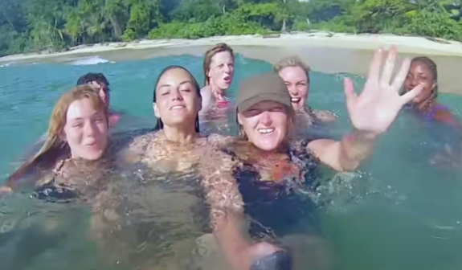

**Note (back to front): Fi,Beth, Georgie, Lauren, Jamie, georgina, and bellinda, (Kate offscreen)**

2081.12 2083.12 SPEAKER_38 Look at this. Nice one.

2083.12 2085.12 SPEAKER_38 Look at this.

2085.12 2087.12 None Oh, my God, it's been so long.

2087.12 2089.12 None Yes!

2089.12 2091.12 SPEAKER_38 Oh, God!

2091.12 2093.12 None Amazing.

2093.12 2095.12 SPEAKER_38 Oh, my God.

2095.12 2097.12 SPEAKER_38 Whoo!

2097.12 2099.12 GEORGIE_46: Oh, no, really?

2099.12 2101.12 GEORGIE_46: Did you ever think we wouldn't make it?

2101.12 2103.12 JAMIE: Oh, honestly, then, we did it.

2103.12 2105.12 GEORGIE_46: I know I'm gonna cry.

2105.12 2107.12 GEORGINA: Come on.

2107.12 2110.12 GEORGINA: This is the most beautiful beach I've ever seen.

2110.12 2116.12 GEORGINA: And, you know, if it was the most disgusting beach, it would still be the most beautiful achievement.

2116.12 2120.12 GEORGINA: Because that in there is horrific.

2120.12 2124.12 FI_58: We're going swimming now in that cool Pacific water.

2124.12 2126.12 FI_58: Whoo!

2126.12 2128.12 None Whoo!

2128.12 2130.12 None Whoo!

2132.12 2134.12 None Whoo!

2134.12 2136.12 None Whoo!

2136.12 2155.12 HOST: With the discovery of the beach comes a lifeline for the women.

2155.12 2159.12 GEORGIE: Honestly, I feel so dry and dehydrated.

2159.12 2162.12 GEORGIE: Basically, my mouth was feeling like Gandhi's flip-flop.

2162.12 2164.12 GEORGIE: No energy.

2165.12 2167.12 GEORGIE: Oh.

2167.12 2171.12 KATE: We can clean our teeth and we can comb our hair.

2171.12 2174.12 KATE: And I found some flip-flops.

2176.12 2182.12 HOST: The expedition party have discovered a beach, but they're yet to find a permanent water source.

2182.12 2184.12 BETH_30: It looks like it might be raining.

2184.12 2188.12 BETH_30: So we might actually be showering all night tonight.

2188.12 2190.12 LAUREN: Shit.

2191.12 2194.12 LAUREN: Going down dark, we have no water.

2194.12 2196.12 LAUREN: We have no fire.

2196.12 2198.12 LAUREN: The sand flies everywhere.

2198.12 2206.12 LAUREN: So, you know, there is potential for it to be amazing, but right now I'm just thinking, oh, my God, how are we going to get through the night?

2207.12 2214.12 HOST: With night drawing in, the women have no choice but to sleep here and return to collect the others in the morning.

2214.12 2216.12 BELINDA: I can actually smell myself.

2216.12 2217.12 SPEAKER_10 Yeah.

2217.12 2219.12 BELINDA: I completely hum.

2219.12 2221.12 BELINDA: The worst thing is our feet.

2221.12 2223.12 SPEAKER_33 Yeah.

2223.12 2227.12 HOST: With no shelter, the group will have to take their chances with the elements.

2227.12 2232.12 GEORGINA: A frustrating thing for me is we all bloody knew to go be prepared.

2234.12 2235.12 JAMIE: Oh, my God.

2235.12 2238.12 HOST: 3am and the heavens have opened.

2239.12 2241.12 JAMIE_30: Shepherding, freezing cold.

2241.12 2242.12 GEORGINA: I don't like this.

2242.12 2251.12 HOST: The women's expedition party discovered a beach to base their camp, but haven't yet found the key to their survival, a sustainable water source.

2251.12 2256.12 GEORGIE: I'm having thunder about, well, all of the plant ponds that we found in our bed.

2256.12 2260.12 HOST: They're soaked through, stranded and dehydrated.

2260.12 2267.12 GEORGIE: What the good thing is about getting this wet is that we can wring out our shirts and suck them, and I'm really not joking.

2268.12 2272.12 FI: At the minute, we are fairly coping with the situation in which we find ourselves.

2272.12 2274.12 FI: Barely.

2274.12 2275.12 BETH Are we?

2275.12 2276.12 FI: Hardly.

2276.12 2278.12 BETH: Hardly, actually.

2278.12 2279.12 BETH Barely.

2279.12 2281.12 FI: Because we didn't prepare properly.

2281.12 2282.12 BETH: No.

2282.12 2283.12 FI: That is the bottom line.

2283.12 2285.12 BETH: And now we're sitting in the fucking rain again.

2285.12 2287.12 FI: Incredible.

**Note: Beth and FI are sharing the same opinion about it being hard**

2287.12 2291.12 HOST: In the height of storm season, the weather can literally change in the blink of an eye.

2291.12 2296.12 HOST: You know, one minute you're going to have scorching sunshine, the next thunder lining torrential rain.

2296.12 2302.12 HOST: And in these sort of extreme conditions, even the thickest jungle canopy is going to give you precious little protection.

2307.12 2310.12 HOST: 7am. It's day four on the island.

2310.12 2317.12 HOST: At their temporary camp, the night of torrential rain has also had a disastrous consequence for the five women left behind.

2317.12 2322.12 CHAVALA: The fire went out last night because of the weather.

2322.12 2325.12 CHAVALA: All the kind of water and everything we need was wet.

2326.12 2331.12 CHAVALA: So when we put it on the fire, it just made the fire die.

2331.12 2332.12 CHAVALA: It's just gone out.

**Abby+Julie+chavala+fran+BEKI =** are stuck behind in the jungle

2332.12 2334.12 HOST: The situation is critical.

2334.12 2340.12 HOST: Without fire, the group have lost their only means of purifying the water from the muddy puddle.

2340.12 2344.12 HOST: They're now down to capturing rainwater in Beth's poncho.

2345.12 2348.12 ABBY This is what we're resorting to now.

2349.12 2351.12 ABBY Rain water.

2352.12 2360.12 HOST: On the other side of the island, the expedition party is also having to rely on an alternative source of hydration.

2361.12 2364.12 JAMIE: I think I've got these cocky huts.

2364.12 2367.12 JAMIE: I'm making my bowels move a little better.

2368.12 2373.12 JAMIE: So I'm going to have to go and look for somewhere to try and do a poo.

2373.12 2376.12 JAMIE: I mean, these will just do this.

2376.12 2378.12 JAMIE: With that on.

2379.12 2382.12 JAMIE: Because I've got no fucking clothes.

2386.12 2392.12 HOST: The women set off along the beach, scouring the area for a sustainable water source.

2392.12 2400.12 KATE: We saw all those women there, and I reckon this is where one of them obviously comes out, because we've got this massive drainage point of all this fresh water.

2401.12 2402.12 LAUREN_24 Hang on.

2402.12 2405.12 LAUREN_24 Are my eyes deceiving me or is that a huge water source?

2408.12 2411.12 LAUREN_24: It's slightly muddy, but it's not salty.

2412.12 2414.12 GEORGINA: We found water.

2414.12 2418.12 LAUREN_24: We just need to find a container now to boil it in and fire.

2419.12 2424.12 HOST: The discovery of the water source means a woman can use this beach as a permanent base.

2424.12 2426.12 BETH_30: Right, let's get going.

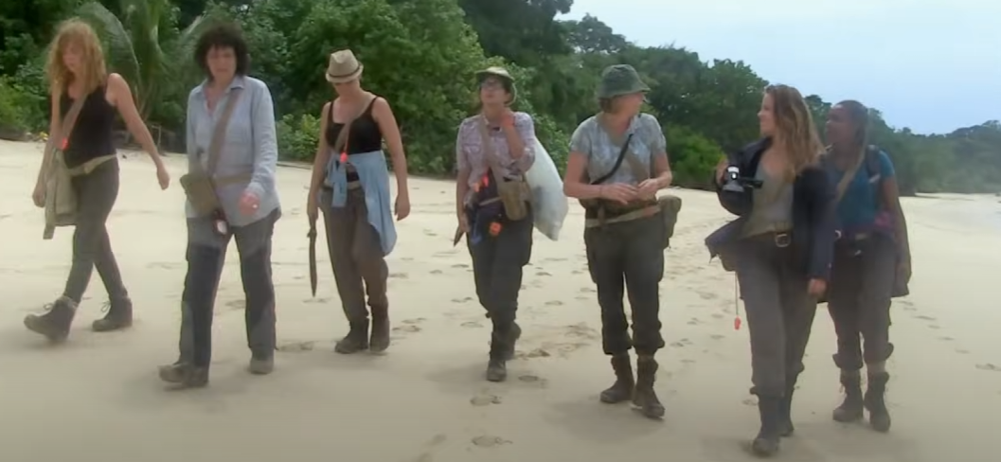

2426.12 2431.12 HOST: But before they make a camp, they face a daunting trek through the jungle to collect the others.

2431.12 2433.12 GEORGINA: Have we got any water again now?

2433.12 2434.12 GEORGIE: No, we've got nothing.

2434.12 2435.12 GEORGINA: Have we not got any water?

2435.12 2436.12 GEORGIE: We've got nothing.

2436.12 2442.12 GEORGIE: So we're going on this trek knowing that we're going to get absolutely fucked and dehydrated.

2442.12 2447.12 FI_58: No, honestly, I have no idea if this is right, but we've made a plan, so we've got to stick to it.

2447.12 2451.12 HOST: Navigating under thick jungle canopy is always going to be difficult.

2451.12 2452.12 HOST: It's going to be unpredictable.

2452.12 2454.12 HOST: You don't get reference points.

2454.12 2456.12 HOST: You haven't got the sun to guide you.

2456.12 2462.12 HOST: And embarking on a journey like that in 30-degree heat with no water, really, you're on borrowed time.

2463.12 2465.12 FI_58: You need to do it like you mean it.

2465.12 2466.12 FI_58: Shall we show you?

2467.12 2468.12 FI_58 Brilliant.

2469.12 2474.12 HOST: The women are marking their path to help find their way back to the beach on their return.

2475.12 2477.12 LAUREN_24: Found a period tree.

2477.12 2479.12 LAUREN_24: It's on its monthly right now.

2479.12 2482.12 FI_58: Let's go this way. It looks like there's a bit of a path.

2482.12 2484.12 FI_58: I think we should be going more that way.

2484.12 2485.12 FI_58: No.

2485.12 2486.12 FI_58: No.

2486.12 2487.12 FI_58: That's going back on ourselves.

2487.12 2491.12 FI_58: Exactly. We've just got to keep going this way, I'm afraid.

2492.12 2494.12 JAMIE_30: This is actually the opposite direction.

2494.12 2496.12 JAMIE_30: This is going back towards the beach.

2496.12 2497.12 JAMIE_30: What the fuck is this?

JAMIE THINKS FI IS GOING THE WRONG DIRECTION (AND THEY WERE, NORTH)

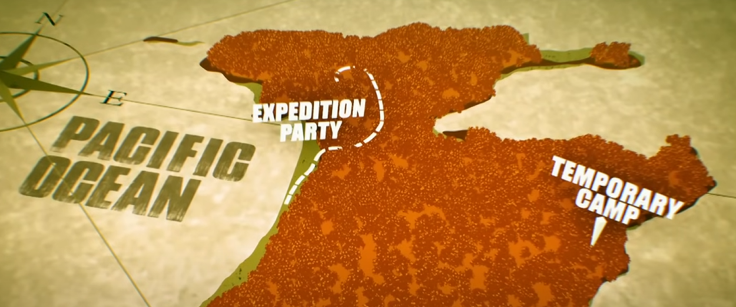

2499.12 2507.12 HOST: The expedition party are deep in the jungle interior and have mistakenly headed north in the wrong direction from their temporary camp.

2507.12 2510.12 HOST: Now completely lost, they're doubling back on themselves.

2512.12 2515.12 BEKI_29: You know, you have to ask yourself the reason they haven't come.

2515.12 2517.12 BEKI_29: Do you think they're not coming?

2517.12 2520.12 BEKI_29: Well, they've got to come back.

**Note: ABBY, FRAN, JULIE, CHAVALA, AND BEKI DON’T THINK THE OTHER GROUP ARE COMING BACK (-1)**

2522.12 2527.12 HOST: Abby and the others have been unable to relight their fire and have run out of drinking water.

2527.12 2530.12 HOST: They are now desperate for the other women to return.

2531.12 2533.12 ABBY: I'm really fed up.

2533.12 2539.12 ABBY: Thursday, Friday, Saturday, Sunday, four days, 100 metres from being dropped off. It's crazy.

2540.12 2543.12 GEORGINA: Which way do you think our current base is?

2543.12 2545.12 FI_58: Well, I think...

2546.12 2548.12 FI_58: It's... Oh, fuck.

2549.12 2551.12 FI_58: I'm so confused, I don't know.

2552.12 2557.12 HOST: The expedition party remain lost and dangerously dehydrated.

2563.12 2564.12 SPEAKER_06 What just happened there?

2564.12 2570.12 BELINDA: It was just calling us, but hopefully the base camp will be able to hear the hello and make a sound back.

2570.12 2573.12 BELINDA: Hello!

2575.12 2576.12 FI: Listen.

2577.12 2578.12 JAMIE: Shush, shush.

2578.12 2580.12 BELINDA: Blow again. It was a one-whistle response.

2580.12 2582.12 None Hello!

2583.12 2584.12 FI: Yeah, that way.

2584.12 2585.12 BETH: They definitely whistled.

2585.12 2590.12 GEORGINA: I wouldn't be surprised if they couldn't find the whistle at the other camp because that's how they didn't reply.

2590.12 2593.12 BELINDA: Hello!

2596.12 2597.12 SPEAKER_27 Fuck.

2597.12 2599.12 BETH_30: That's a fair bird.

2599.12 2600.12 GEORGINA: It's a minor bird.

2600.12 2602.12 JAMIE: So, is this fucking birds?

2602.12 2603.12 GEORGINA: I think it's birds.

2603.12 2604.12 SPEAKER_27 I'm not kidding.

2604.12 2605.12 SPEAKER_27 It's really decisive.

2605.12 2607.12 FI: Right, where the fuck do we go now?

2608.12 2611.12 HOST: Moving through jungle, you get wall after wall of dense undergrowth.

2611.12 2615.12 HOST: And what happens when everything looks the same, it's so easy to lose your bearings.

2615.12 2618.12 HOST: And then you get that rising sense of panic.

2618.12 2620.12 KATE: There's that big tree there.

2620.12 2623.12 KATE: It's got all my slash marks in it from the way we came.

2625.12 2634.12 JAMIE_30: I think you're getting really confused with the directions because if you go up that hill, that's where we just came from, except we came up from a beach there.

2634.12 2638.12 KATE: We did not come from there, Fi, because I've been marking trees all along that route there.

2638.12 2641.12 FI_58: I don't know. There's a much clearer way of saying it.

2641.12 2642.12 FI_58: The ocean...

2642.12 2646.12 KATE: What I would say, Fi, at the moment, is that your way of saying it is that I'm right and everybody else is wrong.

**NOTE: KATE IS ROASTING FI FOR BEING WRONG, FI IS ARROGANT AND THINKS SHE’S THE ONLY ONE THAT IS RIGHT**

**JAMIE IS DEVASTATED AND IS THIRSTY**

2646.12 2652.12 KATE: You're the one who's confident to say, I've got a great sense of direction, but you're not taking anything from anybody else.

2652.12 2655.12 GEORGINA: There's another slash mark here.

2655.12 2657.12 FI_58: Oh, no.

2658.12 2660.12 GEORGINA: We have nothing to drink.

2660.12 2662.12 GEORGINA: We don't know where we are.

2662.12 2663.12 GEORGINA: Let's do a wedding.

2663.12 2666.12 GEORGINA: I can't remember the time I felt this thirsty.

2666.12 2669.12 GEORGINA: How critical do you think our situation is now?

2669.12 2671.12 JAMIE_30: I'm absolutely cracking my pants now.

2671.12 2673.12 JAMIE_30: All I care about is water.

2673.12 2676.12 JAMIE_30: That is all I care about water.

2676.12 2684.12 HOST: It's more than 24 hours since the expedition party left their temporary camp and are now further away than ever.

2684.12 2687.12 HOST: Back at base, the situation is critical, too.

Note: ABBY becomes more impatient with the other group -1

**NOTE: ABBY AND JULIE ARE ALWAYS COOPERATING AND LEADING THE GROUP**

2688.12 2691.12 ABBY: Well, they're not coming for us today, are they? Happy fucking Mondays.

2691.12 2702.12 HOST: The women left behind are struggling to find dry wood to relight the fire, and without this, they can't purify the remaining water in the puddle, and they've barely eaten for four days.

2702.12 2704.12 JULIE: You think we should start a fire? Yes.

2704.12 2707.12 JULIE Do you want to start clearing all our face off the fire?

2707.12 2709.12 FRAN I can't. My heart is beating like a monster.

2709.12 2711.12 JULIE So is everybody's friend.

2711.12 2713.12 JULIE They're all in the same boat.

2713.12 2714.12 JULIE Fucking hell.

2714.12 2716.12 ABBY: Let's not be bitchy, please.

2716.12 2720.12 ABBY: People can manage and people can't, and we'll have our ups and downs, but let's not bitch.

2720.12 2722.12 FRAN: I'm sorry. No.

**NOTE: abby CONSOLES A PANICKING FRAN**

**NOTE: JULIE IS ANNOYED BY FRAN FOR NOT DOING ANYTHING**

2722.12 2724.12 ABBY: Deep breath. Don't talk.

2724.12 2726.12 ABBY: Just come and sit here. Come and sit on the comfy chair.

2726.12 2728.12 ABBY: And sit there.

2733.12 2735.12 ABBY: Don't let anyone fuck you off.

2735.12 2737.12 ABBY: Breathe in slowly, please.

2737.12 2739.12 JULIE: I've got a problem with her crying.

2739.12 2742.12 JULIE: I've got a problem with her sitting on her arse, saying she doesn't feel well.

2742.12 2745.12 JULIE: I'm not doing anything. All our hearts are beating fast.

2745.12 2748.12 FRAN: She did just order me about all the time.

2748.12 2751.12 JULIE: Because she's doing what I do. Oh, my God.

**NOTE: ABBY AND JULIE ARE CONFLICTED OVER FRAN**

2751.12 2753.12 ABBY: No, that's not true. That's absolutely not true.

2753.12 2755.12 FRAN: I tripped the first day. I need you here.

2755.12 2759.12 JULIE: We're in day four now.

ABBY: She needs a fucking rest.

2759.12 2761.12 ABBY: And that's it.

2762.12 2764.12 FRAN: Thank you.

2764.12 2768.12 ABBY: Just remember to how you felt when you felt shit, OK?

2768.12 2770.12 ABBY: Yeah. And leave it there.

2771.12 2774.12 CHAVALA: Tensions in the camp are really high.

2774.12 2776.12 CHAVALA: Oh, my gosh.

2776.12 2779.12 CHAVALA: It's just so hard.

2779.12 2782.12 CHAVALA: And I'm not gonna leave this, so I've got this fit.

2782.12 2785.12 CHAVALA: I don't know how many days.